SQL ASSESSMENT
--> Question 2.1 What are the Top 25 schools (.edu domains)?
Ans:
SELECT
email_domain,
COUNT(*)
FROM users
WHERE email_domain LIKE '%.edu'
GROUP BY 1
ORDER BY 2 DESC
LIMIT 25;
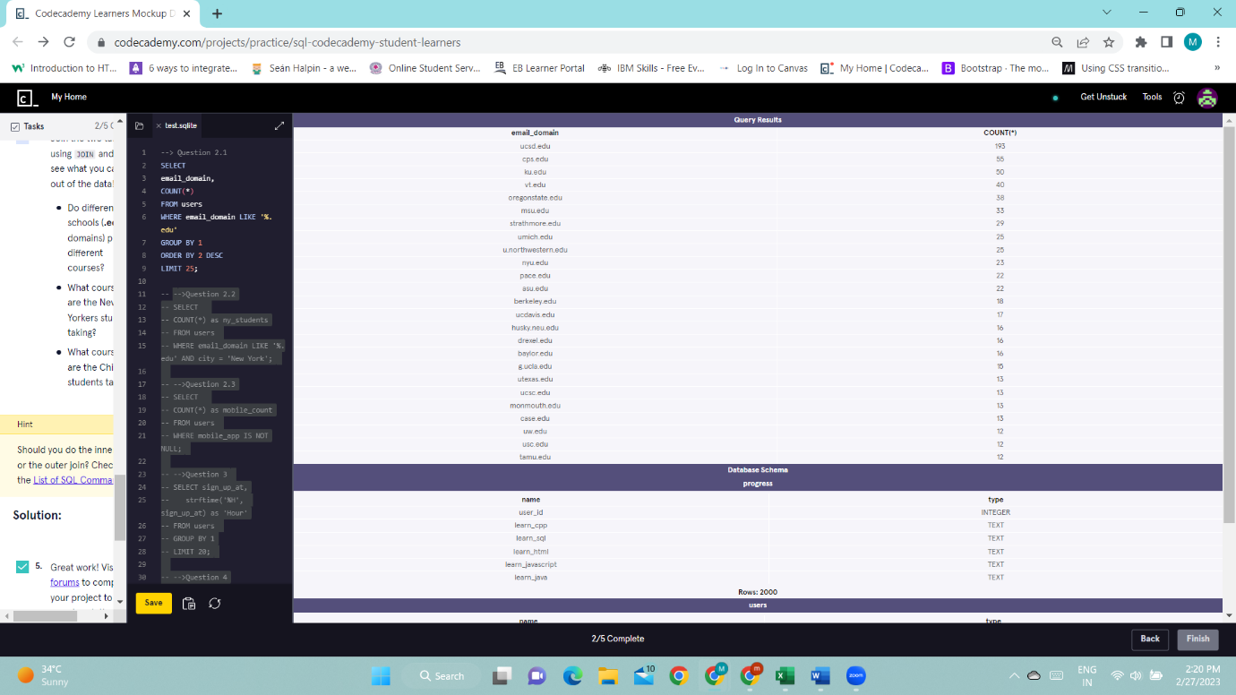

-->Question 2.2 How many .edu learners are located in New York?
Ans:
SELECT
COUNT(*) as ny_students
FROM users
WHERE email_domain LIKE '%.edu' AND city = 'New York';

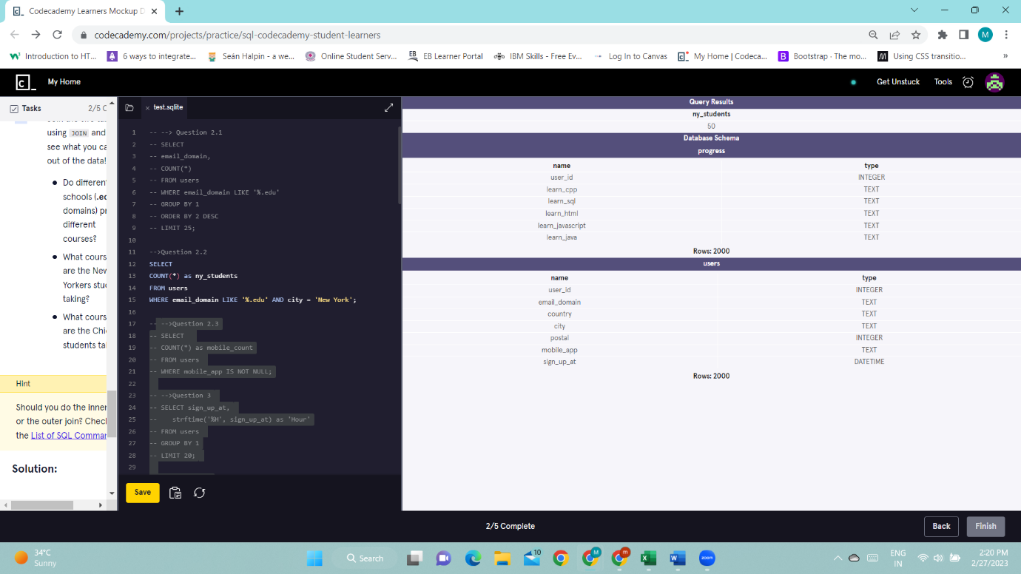
-->Question 2.3 The mobile_app column contains either mobile-user or NULL. How many of these Codecademy learners are using the mobile app?
Ans:

SELECT
COUNT(*) as mobile_count
FROM users
WHERE mobile_app IS NOT NULL;

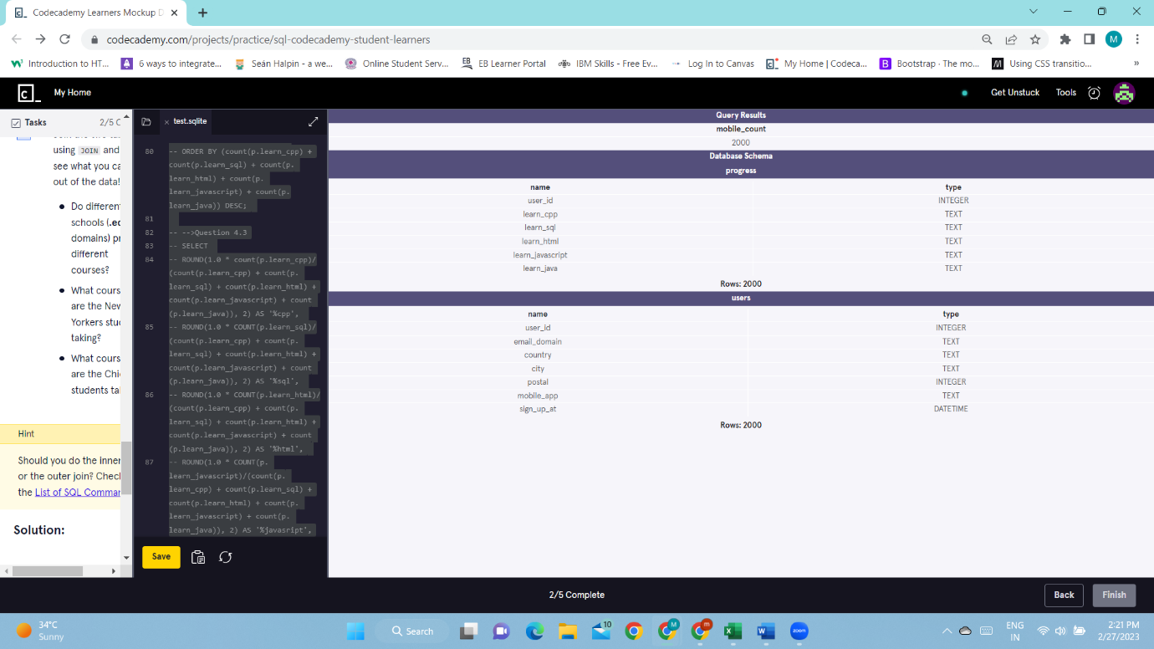

-->Question 3
The data type of the sign_up_at column is DATETIME. It is for storing a date/time value in the database.
Notice that the values are formatted like:
2015-01-01 18:33:52
So the format is:
YYYY-MM-DD HH:MM:SS
SQLite comes with a strftime() function - a very powerful function that allows you to return a formatted date.
It takes two arguments:strftime(format, column)
Let’s test this function out:
SELECT sign_up_at,
strftime('%S', sign_up_at)
FROM users
GROUP BY 1
LIMIT 20;Now, using this function, query for the sign up counts for each hour.
Ans:
SELECT sign_up_at,
strftime('%H', sign_up_at) as 'Hour'
FROM users
GROUP BY 1
LIMIT 20;
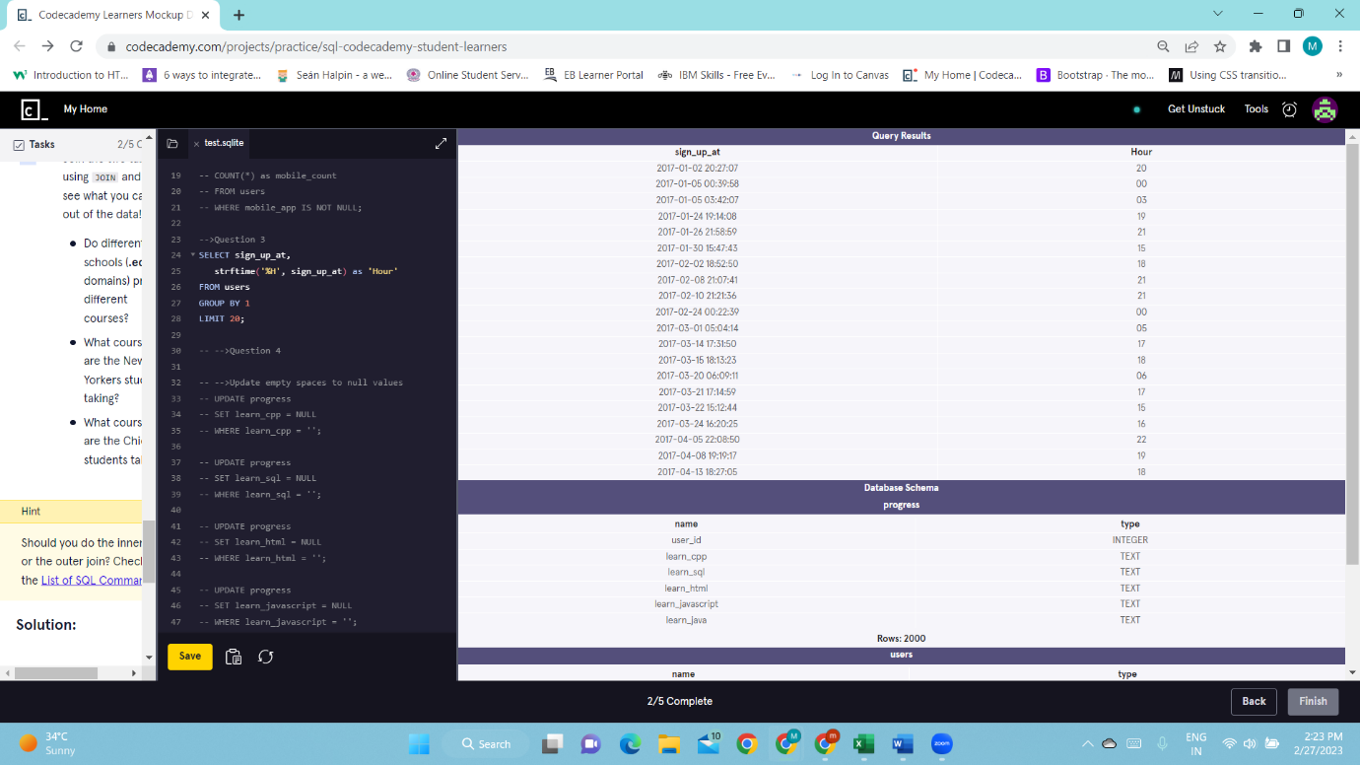
-->Question 4 Join the two tables using JOIN and then see what you can dig out of the data!
Ans:

-->Update empty spaces to null values
UPDATE progress
SET learn_cpp = NULL
WHERE learn_cpp = '';

UPDATE progress
SET learn_sql = NULL
WHERE learn_sql = '';

UPDATE progress
SET learn_html = NULL
WHERE learn_html = '';

UPDATE progress
SET learn_javascript = NULL
WHERE learn_javascript = '';

UPDATE progress
SET learn_java = NULL
WHERE learn_java = '';

-->Question 4.1 Do different schools (.edu domains) prefer different courses?
Ans:
SELECT
email_domain,
ROUND(1.0 * count(p.learn_cpp)/(count(p.learn_cpp) + count(p.learn_sql) + count(p.learn_html) + count(p.learn_javascript) + count(p.learn_java)), 2) AS '%cpp',
ROUND(1.0 * COUNT(p.learn_sql)/(count(p.learn_cpp) + count(p.learn_sql) + count(p.learn_html) + count(p.learn_javascript) + count(p.learn_java)), 2) AS '%sql',
ROUND(1.0 * COUNT(p.learn_html)/(count(p.learn_cpp) + count(p.learn_sql) + count(p.learn_html) + count(p.learn_javascript) + count(p.learn_java)), 2) AS '%html',
ROUND(1.0 * COUNT(p.learn_javascript)/(count(p.learn_cpp) + count(p.learn_sql) + count(p.learn_html) + count(p.learn_javascript) + count(p.learn_java)), 2) AS '%javasript',
ROUND(1.0 * COUNT(p.learn_java)/(count(p.learn_cpp) + count(p.learn_sql) + count(p.learn_html) + count(p.learn_javascript) + count(p.learn_java)), 2) AS '%java'
FROM users u
JOIN progress p
ON u.user_id = p.user_id
WHERE email_domain LIKE '%.edu'
GROUP BY 1
ORDER BY (count(p.learn_cpp) + count(p.learn_sql) + count(p.learn_html) + count(p.learn_javascript) + count(p.learn_java)) DESC
LIMIT 10;
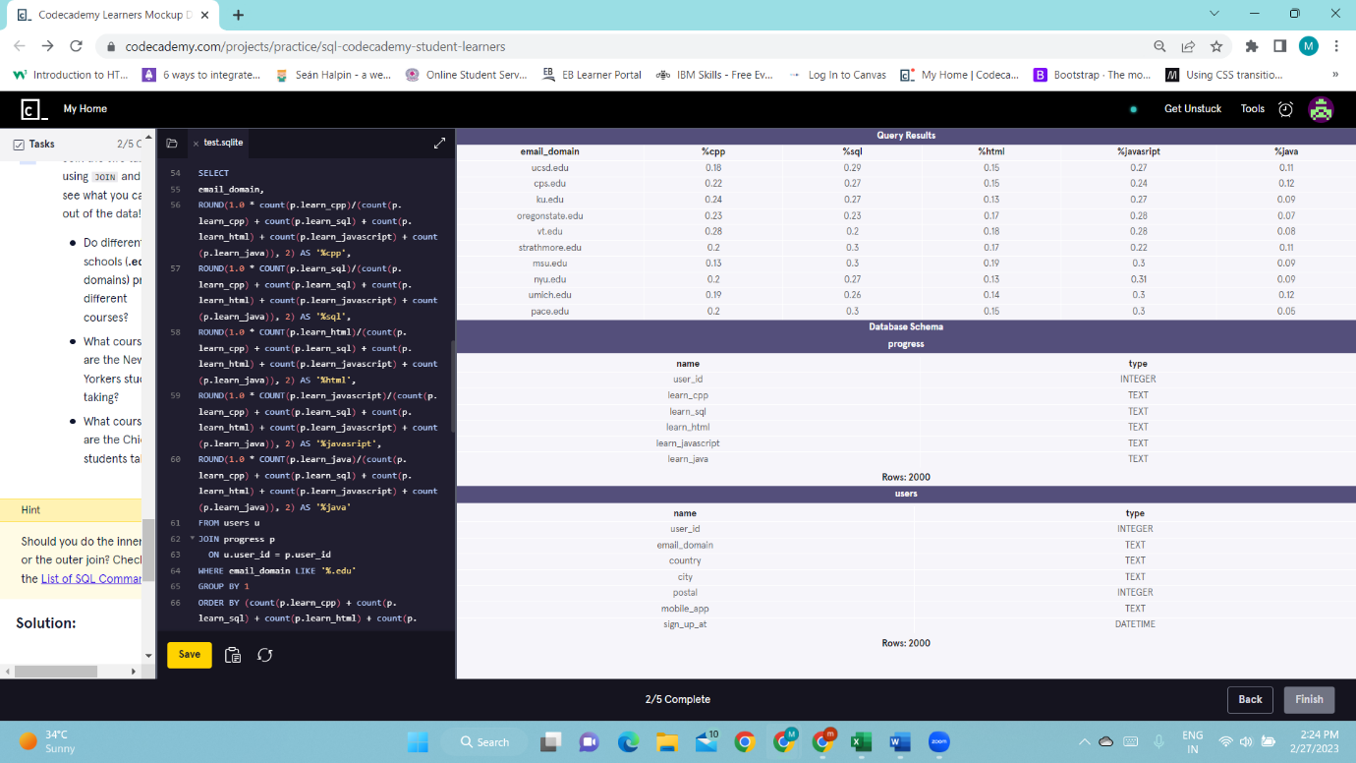
--Question 4.2 What courses are the New Yorkers students taking?
Ans:
SELECT
ROUND(1.0 * count(p.learn_cpp)/(count(p.learn_cpp) + count(p.learn_sql) + count(p.learn_html) + count(p.learn_javascript) + count(p.learn_java)), 2) AS '%cpp',
ROUND(1.0 * COUNT(p.learn_sql)/(count(p.learn_cpp) + count(p.learn_sql) + count(p.learn_html) + count(p.learn_javascript) + count(p.learn_java)), 2) AS '%sql',
ROUND(1.0 * COUNT(p.learn_html)/(count(p.learn_cpp) + count(p.learn_sql) + count(p.learn_html) + count(p.learn_javascript) + count(p.learn_java)), 2) AS '%html',
ROUND(1.0 * COUNT(p.learn_javascript)/(count(p.learn_cpp) + count(p.learn_sql) + count(p.learn_html) + count(p.learn_javascript) + count(p.learn_java)), 2) AS '%javasript',
ROUND(1.0 * COUNT(p.learn_java)/(count(p.learn_cpp) + count(p.learn_sql) + count(p.learn_html) + count(p.learn_javascript) + count(p.learn_java)), 2) AS '%java'
FROM users u
JOIN progress p
ON u.user_id = p.user_id
WHERE city = 'New York'
ORDER BY (count(p.learn_cpp) + count(p.learn_sql) + count(p.learn_html) + count(p.learn_javascript) + count(p.learn_java)) DESC;
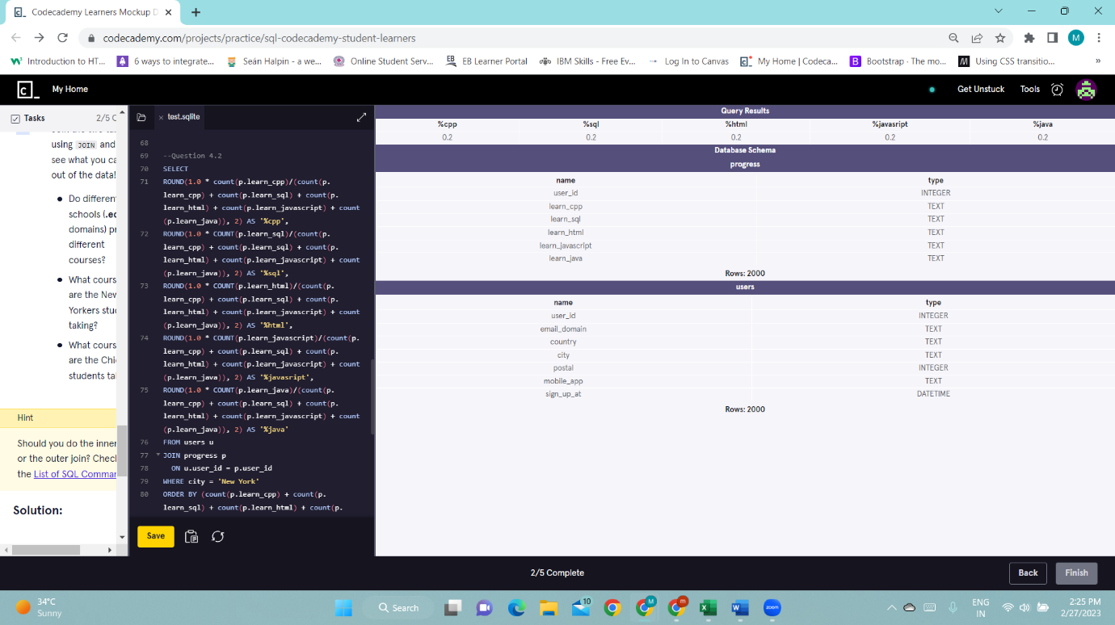

-->Question 4.3 What courses are the Chicago students taking?
Ans:
SELECT
ROUND(1.0 * count(p.learn_cpp)/(count(p.learn_cpp) + count(p.learn_sql) + count(p.learn_html) + count(p.learn_javascript) + count(p.learn_java)), 2) AS '%cpp',
ROUND(1.0 * COUNT(p.learn_sql)/(count(p.learn_cpp) + count(p.learn_sql) + count(p.learn_html) + count(p.learn_javascript) + count(p.learn_java)), 2) AS '%sql',
ROUND(1.0 * COUNT(p.learn_html)/(count(p.learn_cpp) + count(p.learn_sql) + count(p.learn_html) + count(p.learn_javascript) + count(p.learn_java)), 2) AS '%html',
ROUND(1.0 * COUNT(p.learn_javascript)/(count(p.learn_cpp) + count(p.learn_sql) + count(p.learn_html) + count(p.learn_javascript) + count(p.learn_java)), 2) AS '%javasript',
ROUND(1.0 * COUNT(p.learn_java)/(count(p.learn_cpp) + count(p.learn_sql) + count(p.learn_html) + count(p.learn_javascript) + count(p.learn_java)), 2) AS '%java'
FROM users u
JOIN progress p
ON u.user_id = p.user_id
WHERE city = 'New York'
ORDER BY (count(p.learn_cpp) + count(p.learn_sql) + count(p.learn_html) + count(p.learn_javascript) + count(p.learn_java)) DESC;
